SIMATS ENGINEERING
ASSESSMENT TOOL 1: Expert System Development Project
COURSE NAME: | ARTIFICIAL INTELLIGENCE AND EXPERT SYSTEMS | COURSE CODE: | MLA01

COURSE OUTCOME COVERED
CO 5: Construct rule-based expert systems using production rules, forward and backward chaining, and by distinguishing procedural and non-procedural paradigms across development stages.(BTL 3)
Assessment Tool Weightage: 40%
Total Marks: 100 Time: 90 Mins
No. of Questions: 1
Annexure A
Expert System Development Project

Code of Conduct:
I SAHIL J.S (192525200) (Name / Reg No) certify that this submission is my original work and that I have adhered to the guidelines specified for this assessment.
I understand that any violation of academic integrity rules will result in disciplinary action.
Signature of the student: Sahil

Criterion | Weightage | Marks Obtained
1. Problem Analysis and Domain Understanding | 10%
2. Knowledge Acquisition and Knowledge Representation | 10%
3. Production Rule / Knowledge Base Design | 15%
4. Prolog Implementation and Programming | 15%
5. Forward Chaining Implementation and Demonstration | 10%
6. Backward Chaining Implementation and Demonstration | 10%
7. Procedural and Non-Procedural Paradigm Analysis | 10%
8. Unification, Backtracking and Inference Accuracy | 10%
9. Testing, Results and System Demonstration | 5%
10. Documentation, GitHub Repository and Technical Presentation | 5%
Total | 100%

Signature of the Faculty Total Marks Awarded
ANSWER ANY ONE OF THE FOLLOWING
Tool: SWI-Prolog
Usage of Prolog: Students shall use Prolog to develop a rule-based expert system by representing domain knowledge as facts and production rules, and implementing reasoning through forward and backward chaining. The project should demonstrate Prolog's declarative/non-procedural nature, logical inference, rule matching, and automated conclusion generation.
S.No. | Scenario-Based Expert System Development Question
5 | Cybersecurity Threat Diagnosis System:  Construct a rule-based expert system that identifies possible cybersecurity threats from events such as repeated login failures, unusual network traffic, suspicious file activity, and unauthorized access attempts. Implement production rules and demonstrate how forward and backward chaining arrive at a threat classification.

CYBERSECURITY THREAT DIAGNOSIS EXPERT SYSTEM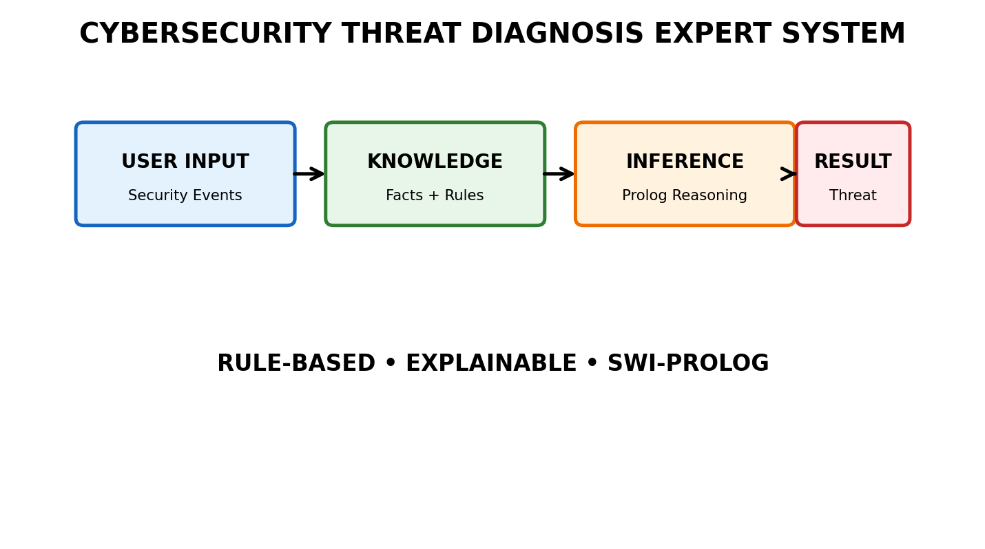1. 2. Problem Analysis and Domain Understanding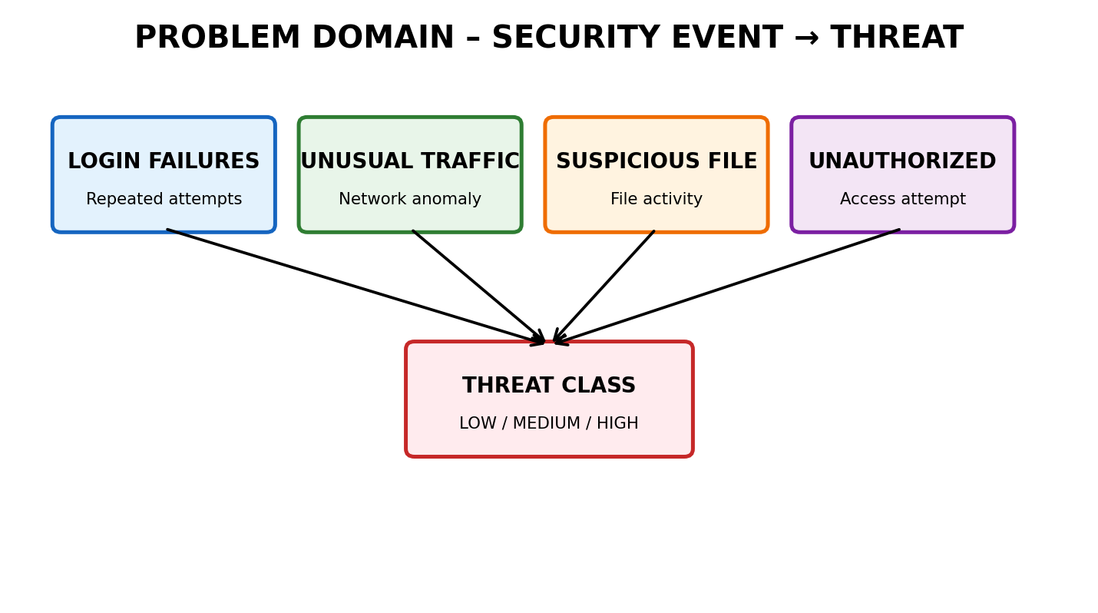
Figure 2. Problem-domain map showing the main cybersecurity indicators.
Cybersecurity monitoring produces many events. A human analyst must combine several indicators before deciding whether an event pattern represents a low, medium, or high-risk threat. The proposed expert system captures a small, explainable set of security rules and automatically derives a threat classification from observed facts.
Element | Project Definition
Problem | Diagnose a probable cybersecurity threat from observable security events.
Entities | User account, login event, network traffic, file activity, access attempt, threat.
Input facts | Repeated login failures, unusual traffic, suspicious file activity, unauthorized access.
Intermediate facts | Credential attack indicator, suspicious activity, high-risk indicator.
Conclusions | Low-risk, medium-risk, or high-risk threat classification.
Goal | Provide an explainable rule-based classification.
2.1 Problem Statement
Develop a SWI-Prolog rule-based expert system that accepts cybersecurity observations as facts, applies production rules, demonstrates forward and backward chaining, and produces an explainable threat classification. The system must support logical inference, unification, backtracking, testing, and technical demonstration.
2.2 Objectives
- Represent cybersecurity knowledge using Prolog facts and rules.
- Design a consistent production-rule knowledge base.
- Implement forward chaining from observed facts to conclusions.
- Use Prolog’s goal-driven inference for backward chaining.
- Demonstrate unification and backtracking through rule matching.
- Generate a clear explanation of the reasoning path.
- Evaluate the system using multiple test scenarios.
3. System Architecture and Workflow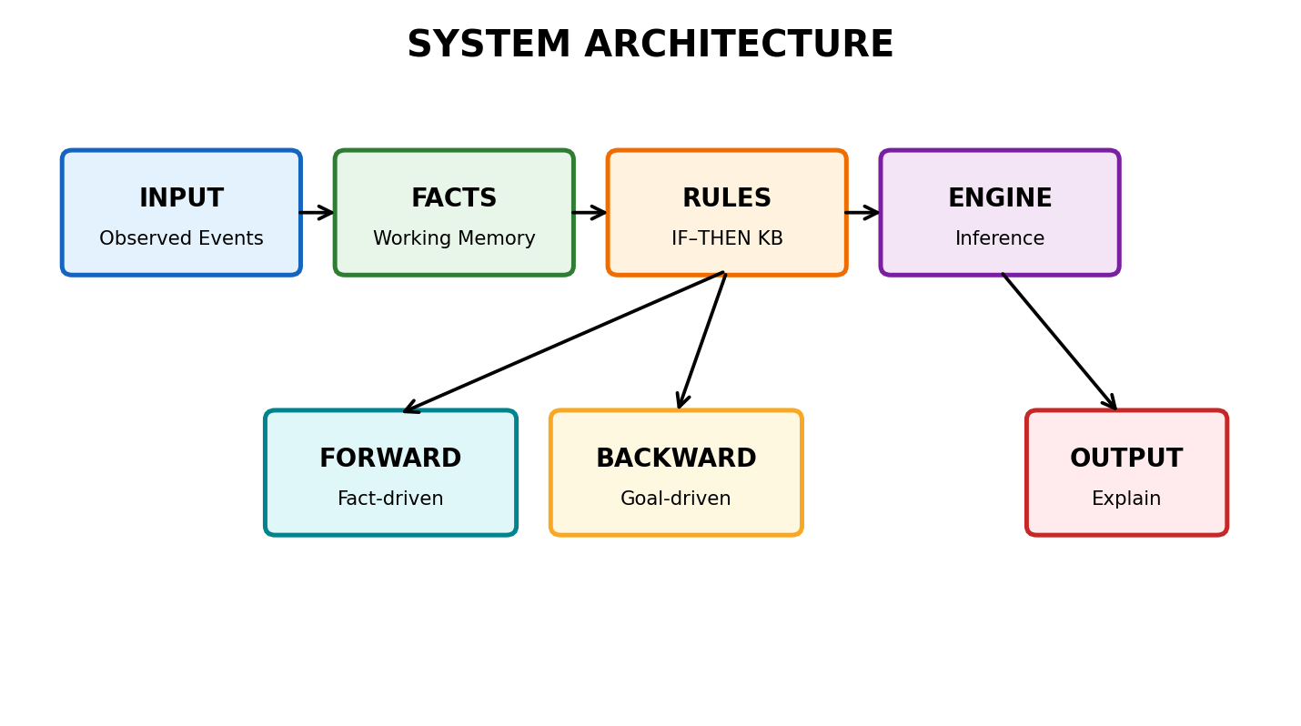
Figure 3. Colour-coded system architecture.
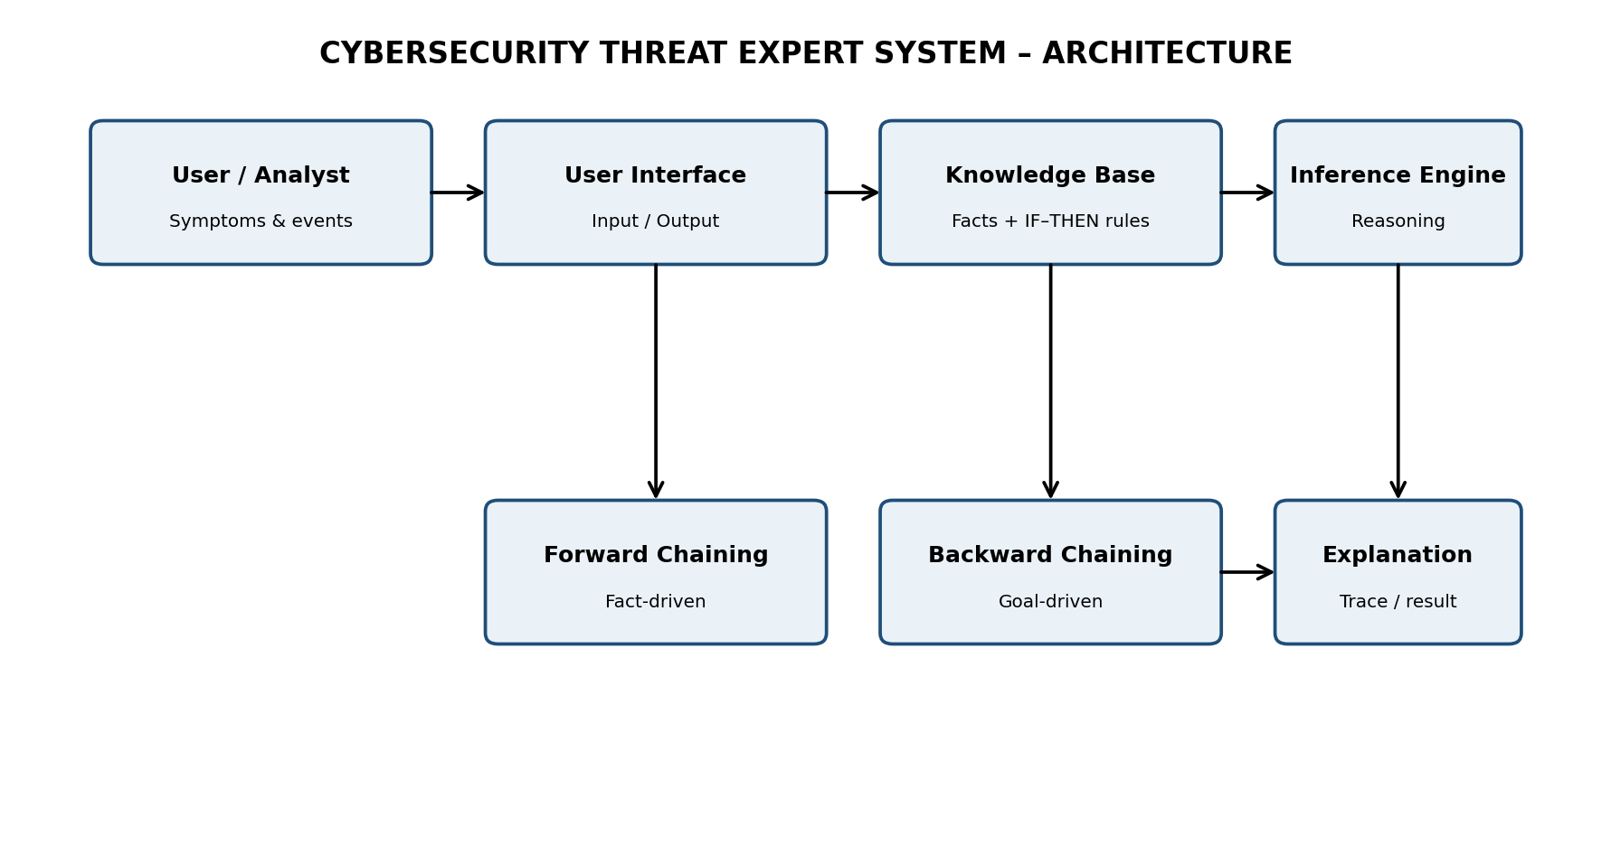
Figure 1. Architecture of the proposed cybersecurity expert system.
3.1 Development Workflow
Stage | Student Activity | Expected Output
1. Domain Analysis | Identify problem domain, entities, facts, conditions, goals and conclusions. | Problem definition and domain model
2. Knowledge Acquisition | Collect and organize relevant cybersecurity knowledge. | Knowledge specification
3. Knowledge Representation | Convert knowledge into IF–THEN production rules. | Knowledge base
4. Inference Design | Implement forward and backward reasoning. | Inference engine
5. Paradigm Analysis | Distinguish procedural and non-procedural approaches. | Paradigm comparison
6. System Development | Integrate knowledge base, inference, interface and explanation. | Working expert system
7. Testing | Test multiple facts and scenarios. | Test cases and outputs
8. Evaluation | Analyze correctness, coverage, consistency and reasoning performance. | Evaluation results
9. Documentation | Prepare technical documentation and GitHub repository. | Project report + GitHub
10. Demonstration | Explain the reasoning process and outputs. | Presentation / viva
The ten stages above follow the supplied report-format requirements. fileciteturn0file0L71-L109
4. Knowledge Acquisition
For this academic prototype, the knowledge is deliberately limited to observable cybersecurity indicators named in the assessment scenario. The rules are written to remain transparent and easy to demonstrate in a viva. The project is an educational decision-support prototype, not a replacement for a production Security Operations Center (SOC).
Knowledge Category | Examples
Authentication events | Repeated login failures
Network behaviour | Unusual network traffic
File behaviour | Suspicious file activity
Access behaviour | Unauthorized access attempts
Derived indicators | Credential attack, suspicious activity, high-risk indicator
Threat classes | Low, medium, high
5. Knowledge Representation and Production Rules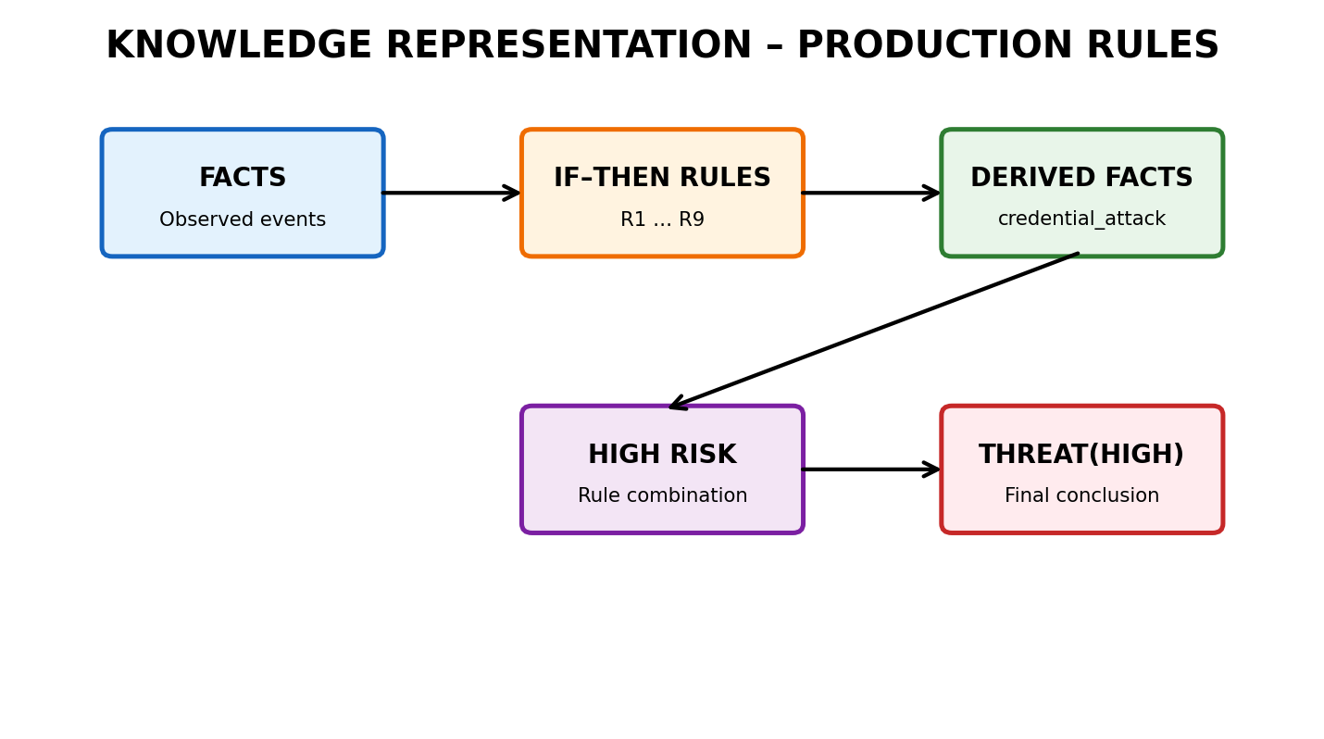
Figure 4. Colour-coded production-rule knowledge map.
The knowledge base uses facts to represent observations and IF–THEN style rules as Prolog clauses. A rule is represented as Head :- Body, meaning that the head can be concluded when the body conditions are satisfied.
Rule ID | IF Conditions | THEN Conclusion
R1 | login_failures(Count), Count > 5 | credential_attack
R2 | unusual_traffic, suspicious_file_activity | suspicious_activity
R3 | credential_attack, unauthorized_access | high_risk
R4 | suspicious_activity, unauthorized_access | high_risk
R5 | unusual_traffic | medium_risk
R6 | suspicious_file_activity | medium_risk
R7 | high_risk | threat(high)
R8 | medium_risk and no high-risk conclusion | threat(medium)
R9 | No high/medium indicators | threat(low)
5.1 Knowledge Base Code
% Cybersecurity Threat Diagnosis Expert System
% SWI-Prolog
% ---------- Initial security observations ----------
observed(login_failures(8)).
observed(unusual_traffic).
observed(suspicious_file_activity).
observed(unauthorized_access).
% ---------- Derived production rules ----------
rule(credential_attack, Facts) :-
member(login_failures(N), Facts),
N > 5.
rule(suspicious_activity, Facts) :-
member(unusual_traffic, Facts),
member(suspicious_file_activity, Facts).
rule(high_risk, Facts) :-
member(credential_attack, Facts),
member(unauthorized_access, Facts).
rule(high_risk, Facts) :-
member(suspicious_activity, Facts),
member(unauthorized_access, Facts).
rule(medium_risk, Facts) :-
member(unusual_traffic, Facts).
rule(medium_risk, Facts) :-
member(suspicious_file_activity, Facts).
% ---------- Threat classification ----------
classify(Facts, high) :-
rule(high_risk, Facts), !.
classify(Facts, medium) :-
rule(medium_risk, Facts), !.
classify(_, low).
% ---------- Forward chaining ----------
forward_chain(Facts, FinalFacts) :-
forward_step(Facts, FinalFacts).
forward_step(Facts, FinalFacts) :-
rule(NewFact, Facts),
\+ member(NewFact, Facts), !,
forward_step([NewFact|Facts], FinalFacts).
forward_step(Facts, Facts).
% ---------- Backward chaining ----------
% Prolog's goal-driven inference is used directly.
threat(High) :-
observed(F1),
observed(F2),
( F1 = login_failures(N), N > 5, F2 = unauthorized_access
; F1 = suspicious_file_activity, F2 = unauthorized_access
),
High = high.
% ---------- Explanation ----------
explain :-
writeln('Reasoning: repeated failures / suspicious activity + unauthorized access -> HIGH threat.').
5.2 Rule Trace Example
Step | Known / Derived Fact | Rule Applied | Reason
1 | login_failures(8) | Initial fact | Observed event.
2 | unauthorized_access | Initial fact | Observed event.
3 | credential_attack | R1 | 8 failures > 5.
4 | high_risk | R3 | credential_attack + unauthorized_access.
5 | threat(high) | R7 | high_risk implies high threat.
6. Forward Chaining Implementation and Demonstration
Forward chaining is fact-driven. The system starts with known observations, checks which rules can fire, adds newly inferred facts, and repeats until no new fact can be derived. The supplied rubric specifically expects the implementation to proceed from initial facts through applicable rules to final conclusions. fileciteturn0file0L232-L260
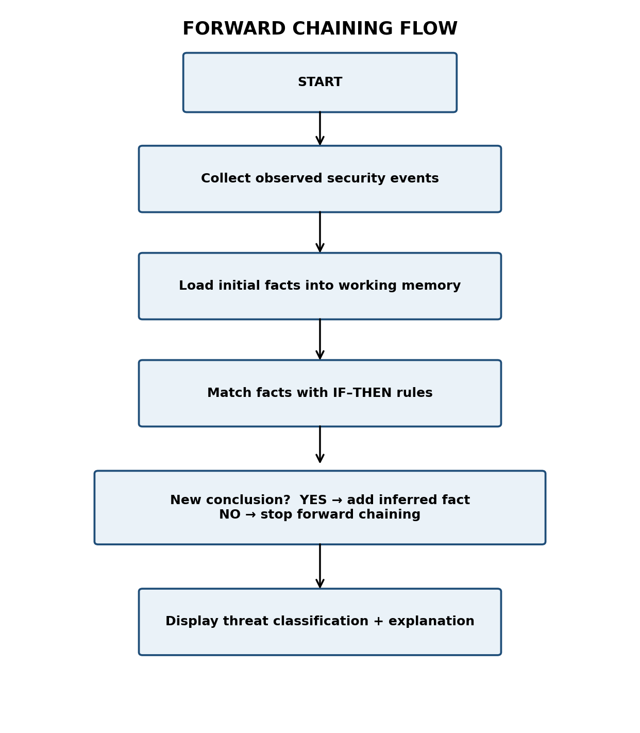
Figure 2. Forward chaining flowchart.
6.1 Forward Chaining Query
?- forward_chain([login_failures(8), unauthorized_access],
FinalFacts).
Expected reasoning:
login_failures(8) -> credential_attack
credential_attack + unauthorized_access -> high_risk
high_risk -> high threat classification
7. Backward Chaining Implementation and Demonstration
Backward chaining is goal-driven. Instead of starting with all available facts, the system begins with a target such as threat(high) and searches for conditions that can prove that goal. Prolog naturally supports this style through its inference mechanism. The supplied rubric expects an effective goal-driven demonstration with a clear reasoning trace. fileciteturn0file0L261-L288
?- threat(high).
true.
?- explain.
Reasoning: repeated failures / suspicious activity + unauthorized access -> HIGH threat.
7.1 Forward vs Backward Reasoning
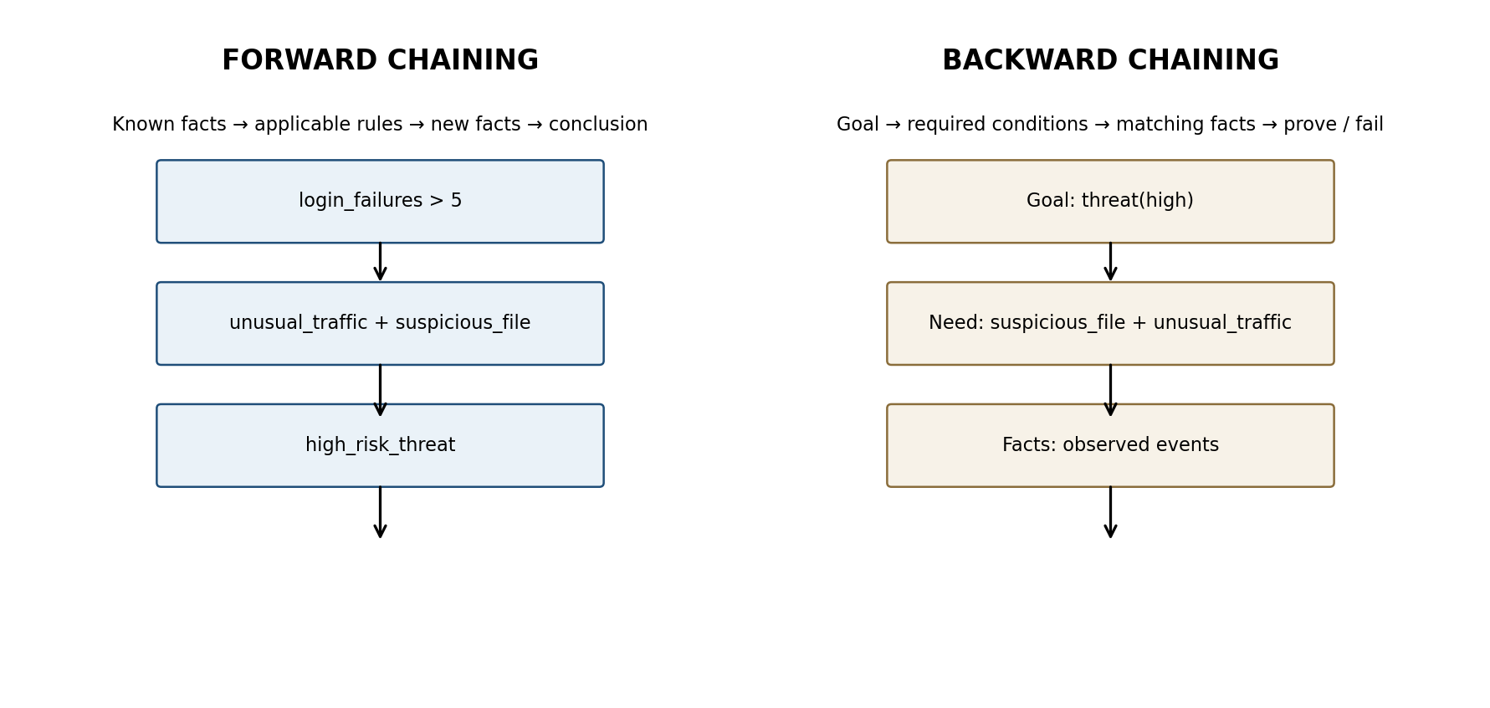
Aspect | Forward Chaining | Backward Chaining
Direction | Facts → conclusion | Goal → supporting facts
Control | Data-driven | Goal-driven
Starting point | Initial observations | Query / hypothesis
Best use | When many facts arrive continuously | When a specific conclusion must be verified
Project example | Events produce high_risk | Prove threat(high)
Prolog role | Custom rule iteration | Native logical inference / query mechanism
8. Procedural and Non-Procedural Paradigm Analysis
The supplied CO5 asks the student to distinguish procedural and non-procedural paradigms across development stages. fileciteturn0file0L7-L10
Feature | Procedural Approach | Prolog / Non-Procedural Approach
Focus | How to perform steps | What facts and relationships are true
Control | Programmer specifies control flow | Inference engine searches for solutions
Knowledge | Often mixed with algorithmic control | Separated as facts and rules
Reasoning | Explicit sequence | Logical inference
Backtracking | Usually implemented manually | Built into Prolog
Project view | Could encode a fixed decision procedure | Rules remain declarative and reusable
In this project, the knowledge base is expressed declaratively, while the inference mechanism determines which rules and facts satisfy a query. This separation makes the system easier to inspect and explain.
9. Unification, Backtracking and Inference Accuracy
Unification allows Prolog to make terms match by finding compatible variable bindings. Backtracking allows Prolog to return to an earlier choice point and try another matching rule when the current path does not satisfy the goal. These mechanisms are central to the reasoning behaviour expected in the rubric. fileciteturn0file0L317-L342
Concept | Project Demonstration
Unification | The query threat(high) matches the head threat(High), binding High = high.
Rule matching | rule(high_risk, Facts) succeeds when required facts occur in Facts.
Backtracking | Alternative high-risk rules can be attempted when one rule path fails.
Inference | Derived facts are combined to produce the final threat class.
Accuracy | Multiple test cases check whether classifications match the supplied observations.
10. Testing, Results and System Demonstration
The assessment requires testing with multiple facts and scenarios and expects accurate outputs and reasoning traces. fileciteturn0file0L343-L365
Test ID | Input Facts | Expected | Observed | Status | Reasoning Trace
TC01 | login_failures(8), unauthorized_access | High | High | Pass | R1 → R3 → R7
TC02 | unusual_traffic, suspicious_file_activity, unauthorized_access | High | High | Pass | R2 → R4 → R7
TC03 | unusual_traffic only | Medium | Medium | Pass | R5
TC04 | suspicious_file_activity only | Medium | Medium | Pass | R6
TC05 | No listed indicators | Low | Low | Pass | R9 / default classification
10.1 Sample Demonstration Output
SWI-Prolog query:
?- classify([login_failures(8), unauthorized_access], Result).
Result:
Result = high.
Explanation:
login_failures(8)
↓
credential_attack
↓
credential_attack + unauthorized_access
↓
high_risk
↓
threat(high)
11. Evaluation
Evaluation Aspect | Observation
Correctness | Rules produce the intended classification for the defined test scenarios.
Coverage | Covers the four event types specified in the selected assessment scenario.
Consistency | Rules are explicit and deterministic for the demonstrated cases.
Explainability | Each conclusion can be traced to facts and rule IDs.
Reasoning performance | The rule set is small, so inference is suitable for classroom demonstration.
Limitation | This prototype does not ingest live security logs or replace professional security monitoring.
12. Documentation and GitHub Repository Structure
The supplied rubric expects complete documentation, a well-organized GitHub repository, clear code, references, and professional presentation. fileciteturn0file0L367-L399
CO5_AT1_Cybersecurity_Expert_System/
│
├── Source_Code/
│ └── cybersecurity_expert_system.pl
│
├── Report/
│ └── CO5_AT1_Expert_System_Development_Project.pdf
│
├── Screenshots/
│ ├── source_code.png
│ ├── forward_chaining_output.png
│ └── backward_chaining_output.png
│
├── Diagrams/
│ ├── architecture.png
│ └── flowchart.png
│
└── README.md
12.1 README Contents
- Project title and objective
- Software requirement: SWI-Prolog
- How to run the .pl file
- Sample queries and outputs
- Forward and backward chaining explanation
- Testing summary
- Team/student details (if applicable)
13. References and Learning Resources
The assessment sheet specifies SWI-Prolog as the project tool and requires students to collect domain knowledge from reliable sources or domain experts. fileciteturn0file0L38-L43
- SIMATS Engineering – CO5 Assessment Tool 1: Expert System Development Project (provided assessment document).
- SWI-Prolog documentation – consult the official documentation when running and debugging the source code.
- Course notes / faculty-provided vStudy materials, where applicable.
14. Code of Conduct and Declaration
I ______________________________ (Name / Reg No) certify that this submission is my original work and that I have adhered to the guidelines specified for this assessment. I understand that any violation of academic integrity rules will result in disciplinary action.
Signature of the Student: __________________________ Date: ________________
15. Evaluation Rubrics – Checklist for Maximum Score
The rubric below is reproduced in a student-friendly checklist while preserving the criteria and weightages from the supplied assessment. The total is 100%. fileciteturn0file0L111-L141

Criterion | Weightage | Maximum-score evidence to include
1. Problem Analysis and Domain Understanding | 10% | Clearly analyze real-world problem, entities, facts, conditions, goals and expected conclusions.
2. Knowledge Acquisition and Representation | 10% | Use relevant domain knowledge and well-structured Prolog facts and rules.
3. Production Rule / Knowledge Base Design | 15% | Provide a comprehensive, consistent and logically structured rule base.
4. Prolog Implementation | 15% | Use facts, predicates, rules, variables, unification and backtracking effectively.
5. Forward Chaining | 10% | Show correct fact-driven reasoning from initial facts to conclusions.
6. Backward Chaining | 10% | Show goal-driven reasoning and trace the inference process.
7. Procedural and Non-Procedural Paradigm Analysis | 10% | Clearly distinguish both approaches and demonstrate the Prolog application.
8. Inference, Unification and Reasoning Accuracy | 10% | Produce accurate conclusions across diverse test cases.
9. Testing, Results and System Demonstration | 5% | Provide comprehensive test cases, accurate outputs, traces and convincing demonstration.
10. Documentation, GitHub and Technical Presentation | 5% | Provide complete documentation, organized repository, clear code, references and professional presentation.
15.1 Final Submission Checklist
- ☐ Source code runs in SWI-Prolog without errors.
- ☐ Knowledge base contains facts and IF–THEN production rules.
- ☐ Forward chaining is demonstrated with a visible reasoning trace.
- ☐ Backward chaining is demonstrated using a goal query.
- ☐ Procedural vs non-procedural comparison is included.
- ☐ Unification and backtracking are explained with project examples.
- ☐ At least five test cases with expected/observed results are documented.
- ☐ Architecture and flowchart diagrams are included.
- ☐ Code/output screenshots are inserted before final submission.
- ☐ GitHub repository is organized into Source_Code, Report, Screenshots and Diagrams.
- ☐ README contains run instructions and sample queries.
- ☐ Viva explanation is prepared for every rubric criterion.
16. Conclusion
The completed design satisfies the structure of the supplied CO5 Expert System Development Project: domain analysis, knowledge acquisition, knowledge representation, production-rule design, Prolog implementation, forward and backward chaining, paradigm analysis, inference concepts, testing, documentation, and demonstration. The final source should be executed in SWI-Prolog and the actual source/output screenshots should be inserted into the report before submission.

17. PROJECT VISUALS & DEMONSTRATION GALLERY

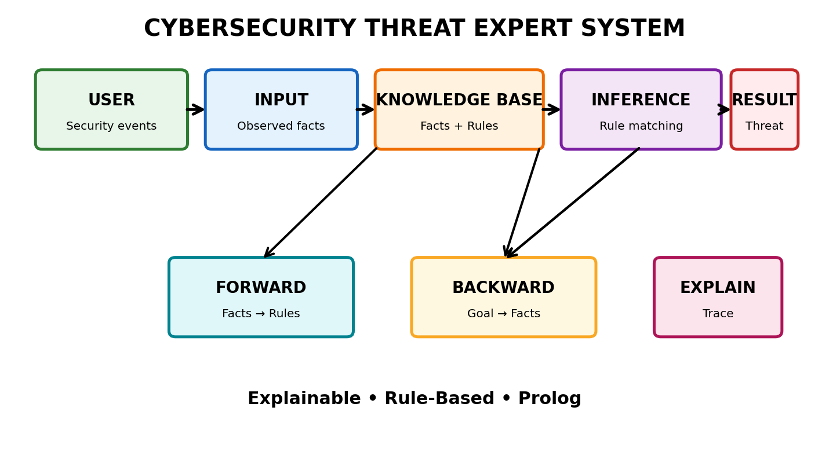
Figure 3. Colour-coded architecture of the cybersecurity expert system.

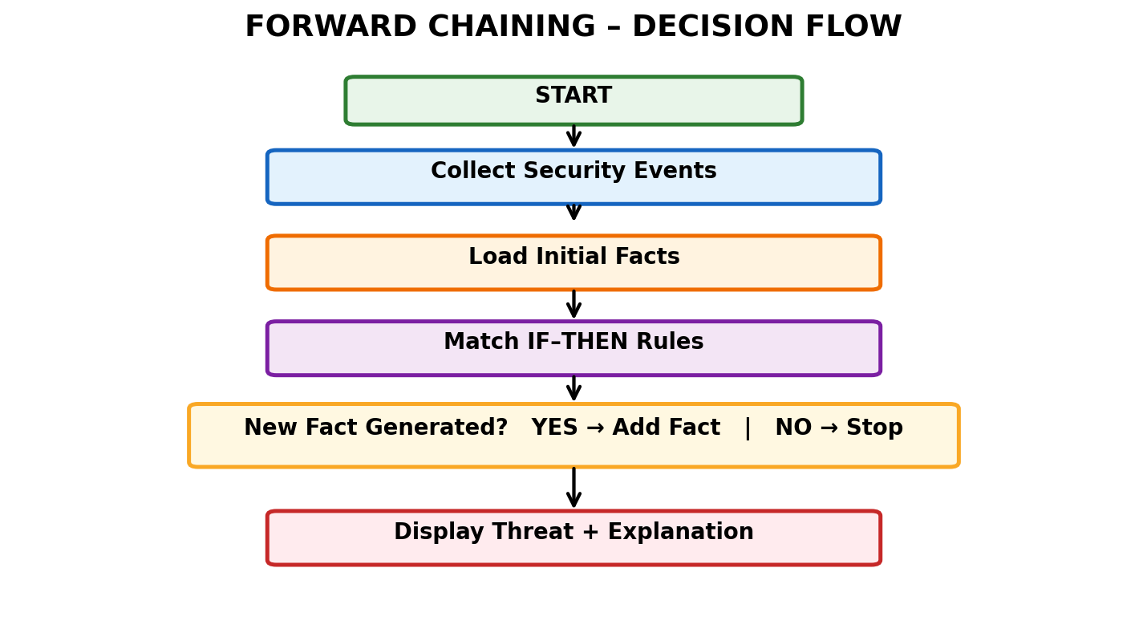
Figure 4. Colour-coded forward-chaining decision flow.

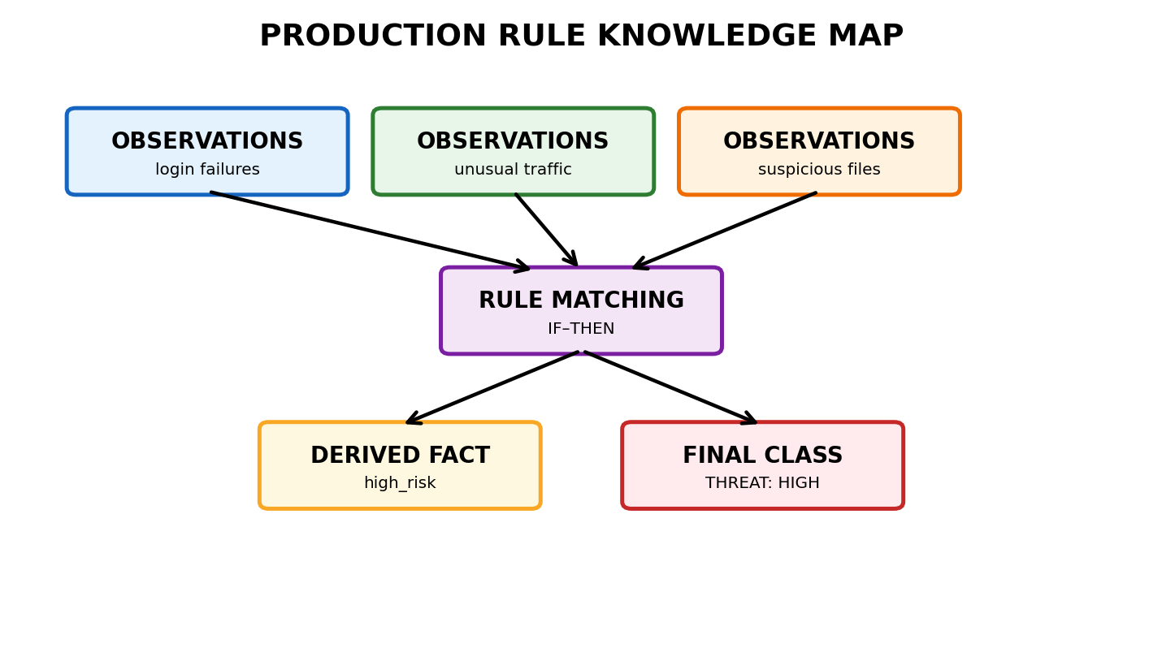
Figure 5. Production-rule knowledge map.

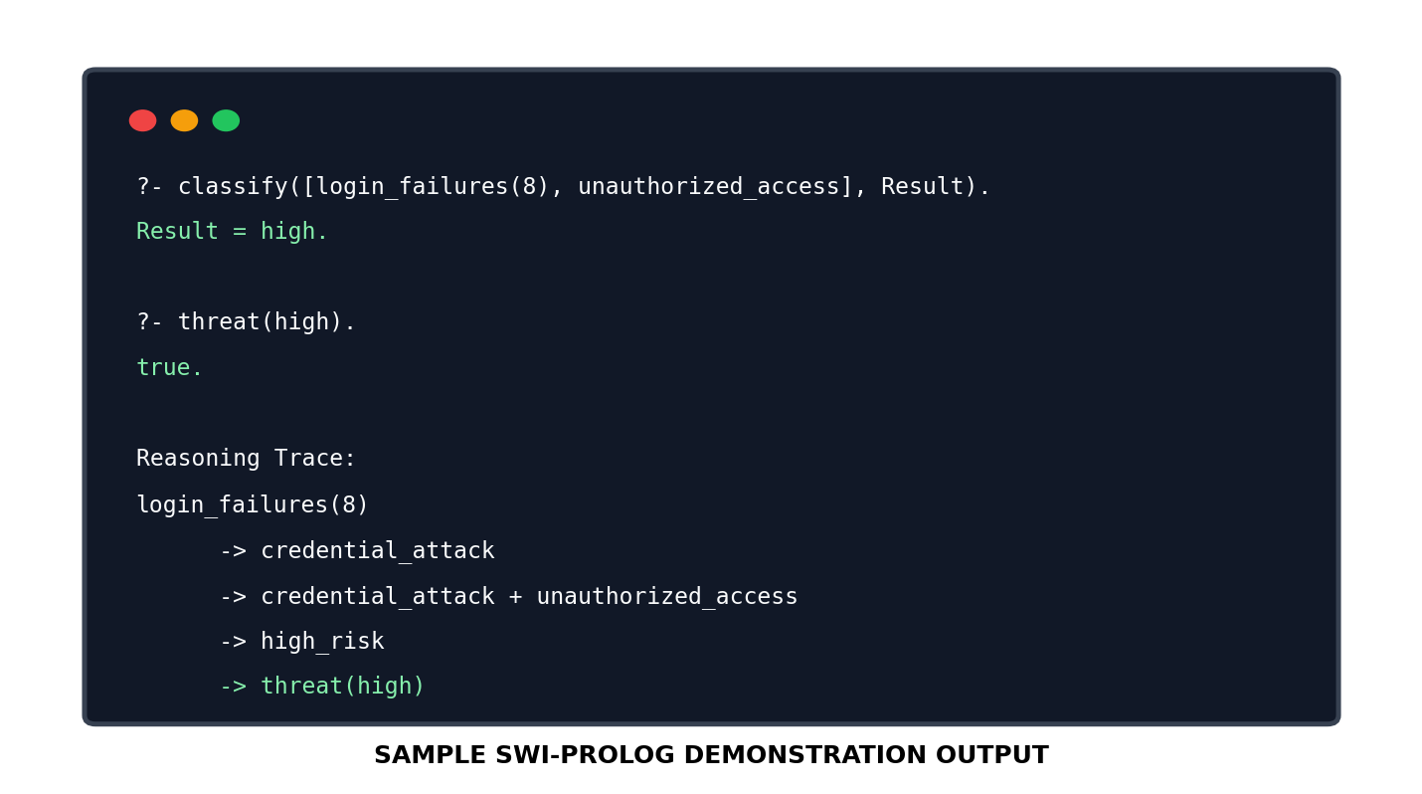
Figure 6. Sample SWI-Prolog demonstration output — replace/augment with the actual run screenshot before submission.
EVALUATION RUBRICS:

Criterion | Weightage (%) | Excellent | Good | Average | Poor
1. Problem Analysis and Domain Understanding | 10% | 9–10% – Clearly analyzes the real-world problem, domain entities, facts, conditions, goals, and expected conclusions. | 7–8% – Good understanding of the domain with minor omissions. | 5–6% – Basic domain understanding with several missing elements. | 0–4% – Poor or incorrect understanding of the problem domain.
2. Knowledge Acquisition and Representation | 10% | 9–10% – Acquires relevant domain knowledge and represents it accurately using well-structured Prolog facts and rules. | 7–8% – Knowledge is appropriately represented with minor gaps. | 5–6% – Basic knowledge representation with missing or unclear facts/rules. | 0–4% – Inadequate or inappropriate knowledge representation.
3. Production Rule / Knowledge Base Design | 15% | 13–15% – Develops a comprehensive, consistent, and logically structured production-rule knowledge base with appropriate facts and rules. | 10–12% – Well-designed knowledge base with minor inconsistencies or omissions. | 7–9% – Basic rule base developed but several rules are incomplete or unclear. | 0–6% – Knowledge base is incomplete, inconsistent, or inappropriate.
4. Prolog Implementation | 15% | 13–15% – Implements a fully functional expert system using Prolog facts, predicates, rules, variables, unification, and backtracking effectively. | 10–12% – Functional Prolog implementation with minor technical issues. | 7–9% – Basic implementation works with limited use of Prolog features. | 0–6% – Implementation is incomplete, incorrect, or non-functional.
5. Forward Chaining | 10% | 9–10% – Correctly implements and demonstrates forward chaining from initial facts through applicable rules to final conclusions. | 7–8% – Forward chaining works correctly with minor limitations. | 5–6% – Basic forward reasoning demonstrated but with incomplete rule processing. | 0–4% – Forward chaining is missing or incorrectly implemented.
6. Backward Chaining | 10% | 9–10% – Effectively demonstrates goal-driven backward chaining using Prolog's inference mechanism and clearly traces the reasoning process. | 7–8% – Backward chaining works correctly with minor gaps. | 5–6% – Basic backward reasoning demonstrated with limited explanation. | 0–4% – Backward chaining is missing or incorrectly implemented.
7. Procedural and Non-Procedural Paradigm Analysis | 10% | 9–10% – Clearly distinguishes procedural and declarative/non-procedural approaches and demonstrates their application in the Prolog system. | 7–8% – Provides a good distinction with minor conceptual gaps. | 5–6% – Basic distinction is explained but lacks practical demonstration. | 0–4% – Paradigms are misunderstood or not addressed.
8. Inference, Unification and Reasoning Accuracy | 10% | 9–10% – Produces accurate conclusions using unification, backtracking, and logical inference across diverse test cases. | 7–8% – Reasoning is mostly accurate with minor errors. | 5–6% – Basic inference works but produces occasional incorrect results. | 0–4% – Inference is unreliable or incorrect.
9. Testing, Results and System Demonstration | 5% | 5% – Provides comprehensive test cases, accurate outputs, reasoning traces, and a convincing live demonstration. | 4% – Good testing and demonstration with minor gaps. | 2–3% – Limited test cases and basic demonstration. | 0–1% – Testing or demonstration is missing/inadequate.
10. Documentation, GitHub and Technical Presentation | 5% | 5% – Complete documentation, well-organized GitHub repository, clear code, references, and professional presentation. | 4% – Good documentation and repository with minor issues. | 2–3% – Basic documentation/repository with several omissions. | 0–1% – Poor documentation, missing repository, or inadequate presentation.
Total | 100%

